Contents

Database Creation Script 2

Database Creation Screenshot 4

Data Import Script 5

Data Import Screen Shot 6

Setting Primary Keys Script 6

Setting Foreign Keys Script 7

Unique Constraint on Primary Keys 13

# Database Creation Script

CREATE DATABASE StudentAccomodation;

CREATE TABLE NextOfKin (

NOK_ID INTEGER (7) NOT NULL,

NOK_Name TEXT,

NOK_Relation TINYTEXT,

NOK_Address_Street TEXT,

NOK_Address_City TEXT,

NOK_Address_PCODE TEXT,

NOK_Phone TEXT,

NOK_Student_ID INTEGER (7)

);

CREATE TABLE Courses (

Course_ID INTEGER (7) NOT NULL,

Course_Title TEXT,

Course_Year TEXT,

Course_Leader TEXT,

Course_Phone TEXT,

Course_Room TEXT,

Course_Dept TEXT

);

CREATE TABLE PaymentMethods (

Payment_Code INTEGER (4) NOT NULL,

Payment_Descr TEXT

);

CREATE TABLE StudentPaymentDetails (

Details_Code INTEGER (7) NOT NULL,

Details_Payment_Code INTEGER (4),

Details_Student_ID INTEGER (7),

Details_Card_Account_Number TEXT,

Details_Card_Sort_Code TEXT

);

CREATE TABLE Invoice (

Invoice_Num INTEGER (7) NOT NULL,

Invoice_Lease_Num INTEGER (7),

Invoice_Student_ID INTEGER (7),

Invoice_Place_Num INTEGER (7),

Invoice_Pay_Date DATE,

Invoice_Pay_Amount DECIMAL,

Invoice_Payment_Code INTEGER (7),

Invoice_First_Reminder DATE,

Invoice_Second_Reminder DATE,

);

CREATE TABLE StudentAddress (

Stud_Address_ID INTEGER (7) NOT NULL,

Stud__Uni_Add_ID INTEGER (7),

Stud_Lease_ID INTEGER (7),

Stud_Place_Num INTEGER (7),

Stud_Student_ID INTEGER (7)

);

CREATE TABLE Lease (

Lease_Num INTEGER (7) NOT NULL,

Lease_Duration TEXT,

Lease_Rent_Rate DECIMAL,

Lease_Start_Date DATE,

Lease_Finish_Date DATE,

Lease_Student_ID INTEGER (7),

Lease_Place_Num INTEGER (7),

Lease_Student_Add_ID INTEGER (7)

);

CREATE TABLE FlatInspections (

Inspect_ID INTEGER (7) NOT NULL,

Inspect_Staff_ID INTEGER (7),

Inspect_Date DATE,

Inspect_Condition TEXT,

Inspect_Comments TEXT,

Inspect_Place_Num INTEGER (7)

);

CREATE TABLE Staff (

Staff_ID INTEGER (7) NOT NULL,

Staff_Name TEXT,

Staff_Address_Street TEXT,

Staff_Address_City TEXT,

Staff_Address_Pcode TEXT,

Staff_DOB DATE,

Staff_Position TEXT,

Staff_Location_ID INTEGER (7)

);

CREATE TABLE Address (

Add_ID INTEGER (7) NOT NULL,

Add_Uni_Accom_ID INTEGER (7),

Add_Street TEXT,

Add_City TEXT,

Add_PCode TEXT

);

CREATE TABLE UniAccomodation (

Uni_Accom_ID INTEGER (7) NOT NULL,

Uni_Accom_Type TEXT,

Uni_Accom_Building_Name TEXT,

Uni_Accom_Num_Of_Rooms INTEGER (4),

Uni_Accom_Staff_ID INTEGER (7),

Uni_Accom_Add_ID INTEGER (7)

);

CREATE TABLE Room (

Place_Num INTEGER (7) NOT NULL,

Room_Number TEXT,

Room_Uni_Accom_ID INTEGER (7)

);

CREATE TABLE Student (

Student_ID INTEGER (7) NOT NULL,

Student_First_Name TEXT,

Student_Second_Name TEXT,

Stud_Home_Add_ID INTEGER (7),

Student_NOK_ID INTEGER (7),

Student_Date_Left_Uni INTEGER (7),

Student_Email TEXT,

Student_Category TEXT,

Student_Nationality TEXT,

Student_Smoker CHAR (1),

Student_Special_Needs TEXT,

Student_Comments TEXT,

Student_Placed CHAR (1),

Student_Course_ID INTEGER (7),

Student_Place_Num INTEGER (7)

);

CREATE TABLE HomeAddress (

Home_Add_ID INTEGER (7) NOT NULL,

Home_Student_ID INTEGER (7),

Home_Add_Street TEXT,

Home_Add_City TEXT,

Home_Add_PCode TEXT

);

# Database Creation Screenshot

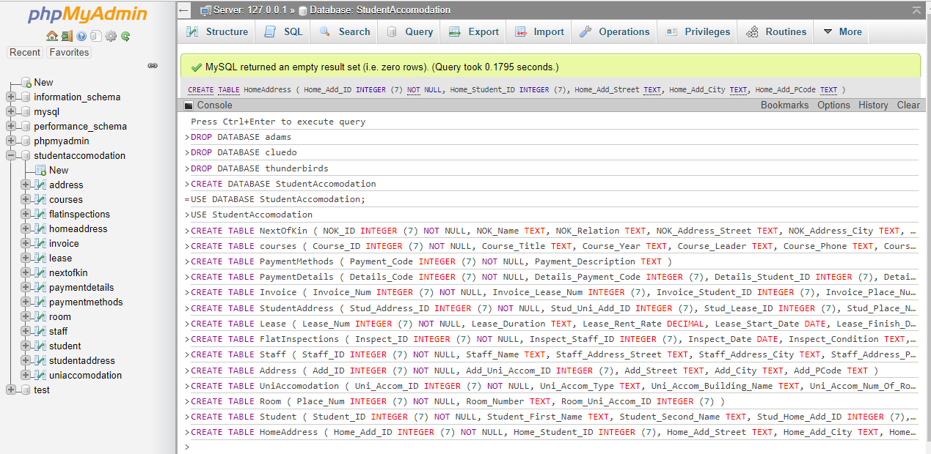

# Data Import Script

LOAD DATA INFILE 'c:/Address_Data.csv'

INTO TABLE address

FIELDS TERMINATED BY ','

LINES TERMINATED BY '\n'

IGNORE 1 ROWS;

LOAD DATA INFILE 'c:/Course_Data.csv'

INTO TABLE courses

FIELDS TERMINATED BY ','

LINES TERMINATED BY '\n'

IGNORE 1 ROWS;

LOAD DATA INFILE 'c:/FlatInspections_Data.csv'

INTO TABLE flatinspections

FIELDS TERMINATED BY ','

LINES TERMINATED BY '\n'

IGNORE 1 ROWS;

LOAD DATA INFILE 'c:/Home_Data.csv'

INTO TABLE homeaddress

FIELDS TERMINATED BY ','

LINES TERMINATED BY '\n'

IGNORE 1 ROWS;

LOAD DATA INFILE 'c:/Invoice_Data.csv'

INTO TABLE invoice

FIELDS TERMINATED BY ','

LINES TERMINATED BY '\n'

IGNORE 1 ROWS;

LOAD DATA INFILE 'c:/Lease_Data.csv'

INTO TABLE lease

FIELDS TERMINATED BY ','

LINES TERMINATED BY '\n'

IGNORE 1 ROWS;

LOAD DATA INFILE 'c:/NOK_Data.csv'

INTO TABLE nextofkin

FIELDS TERMINATED BY ','

LINES TERMINATED BY '\n'

IGNORE 1 ROWS;

LOAD DATA INFILE 'c:/Staff_Data.csv'

INTO TABLE staff

FIELDS TERMINATED BY ','

LINES TERMINATED BY '\n'

IGNORE 1 ROWS;

LOAD DATA INFILE 'c:/Student_Data.csv'

INTO TABLE student

FIELDS TERMINATED BY ','

LINES TERMINATED BY '\n'

IGNORE 1 ROWS;

LOAD DATA INFILE 'c:/StudentAddress_Data.csv'

INTO TABLE studentaddress

FIELDS TERMINATED BY ','

LINES TERMINATED BY '\n'

IGNORE 1 ROWS;

LOAD DATA INFILE 'c:/Uni_Accom_Data.csv'

INTO TABLE uniaccomodation

FIELDS TERMINATED BY ','

LINES TERMINATED BY '\n'

IGNORE 1 ROWS;

# Data Import Screen Shot

# Setting Primary Keys Script

ALTER TABLE address

ADD PRIMARY KEY (Add_ID);

ALTER TABLE courses

ADD PRIMARY KEY (Course_ID);

ALTER TABLE flatinspections

ADD PRIMARY KEY (Inspect_ID);

ALTER TABLE homeaddress

ADD PRIMARY KEY (Home_Add_ID);

ALTER TABLE invoice

ADD PRIMARY KEY (Invoice_Num);

ALTER TABLE lease

ADD PRIMARY KEY (Lease_Num);

ALTER TABLE nextofkin

ADD PRIMARY KEY (NOK_ID);

ALTER TABLE paymentdetails

ADD PRIMARY KEY (Details_Code);

ALTER TABLE paymentmethods

ADD PRIMARY KEY (Payment_Code);

ALTER TABLE room

ADD PRIMARY KEY (Place_Num);

ALTER TABLE staff

ADD PRIMARY KEY (Staff_ID);

ALTER TABLE student

ADD PRIMARY KEY (Student_ID);

ALTER TABLE studentaddress

ADD PRIMARY KEY (Stud_Address_ID);

ALTER TABLE uniaccomodation

ADD PRIMARY KEY (Uni_Accom_ID);

# Setting Foreign Keys Script

ALTER TABLE paymentdetails

ADD FOREIGN KEY (Details_Payment_Code)

REFERENCES

paymentmethods(Payment_Code);

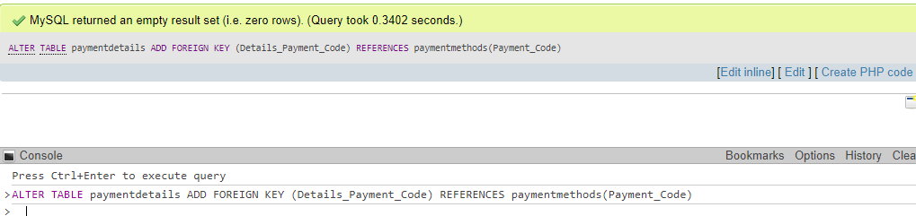

ALTER TABLE lease

ADD FOREIGN KEY (Lease_Student_ID)

REFERENCES

student(Student_ID);

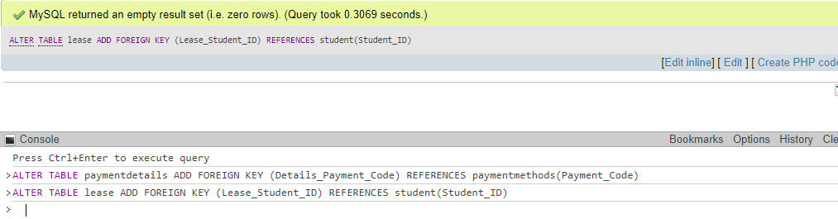

ALTER TABLE lease

ADD FOREIGN KEY (Lease_Place_Num)

REFERENCES

room(Place_Num);

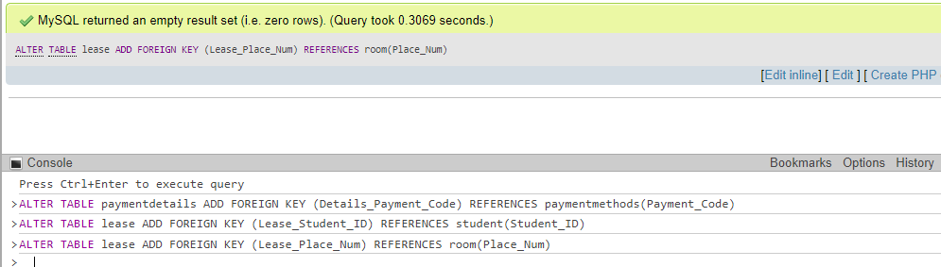

ALTER TABLE lease

ADD FOREIGN KEY (Lease_Student_Add_ID)

REFERENCES

studentaddress (Stud_Address_ID);

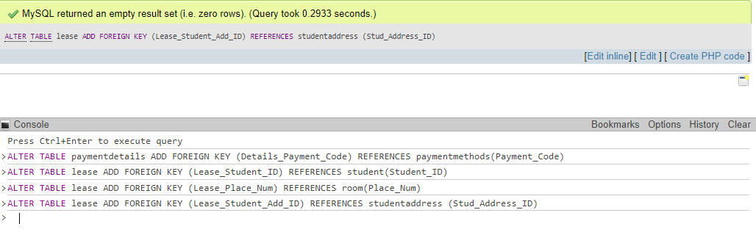

ALTER TABLE invoice

ADD FOREIGN KEY (Invoice_Lease_Num)

REFERENCES

lease (Lease_Num);

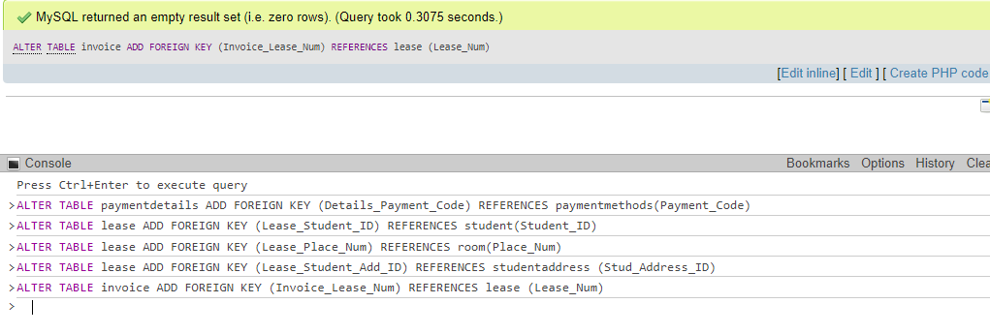

ALTER TABLE invoice

ADD FOREIGN KEY (Invoice_Student_ID)

REFERENCES

student (Student_ID);

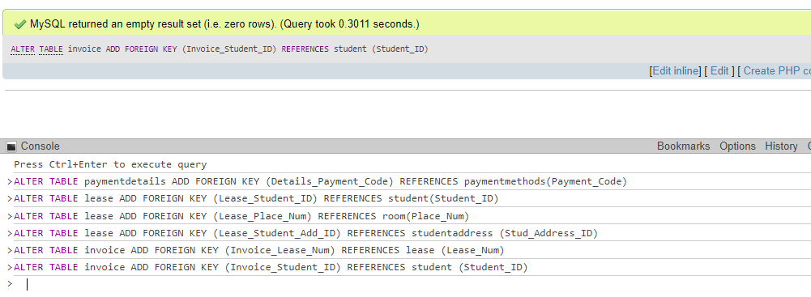

ALTER TABLE invoice

ADD FOREIGN KEY (Invoice_Place_Num)

REFERENCES

room (Place_Num);

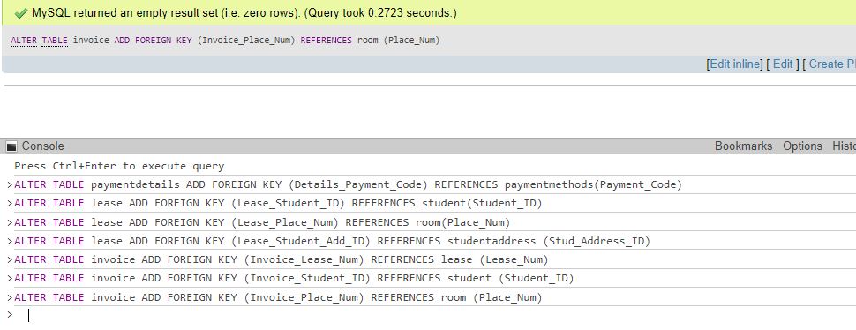

ALTER TABLE invoice

ADD FOREIGN KEY (Invoice_Payment_Code)

REFERENCES

paymentdetails (Details_Code);

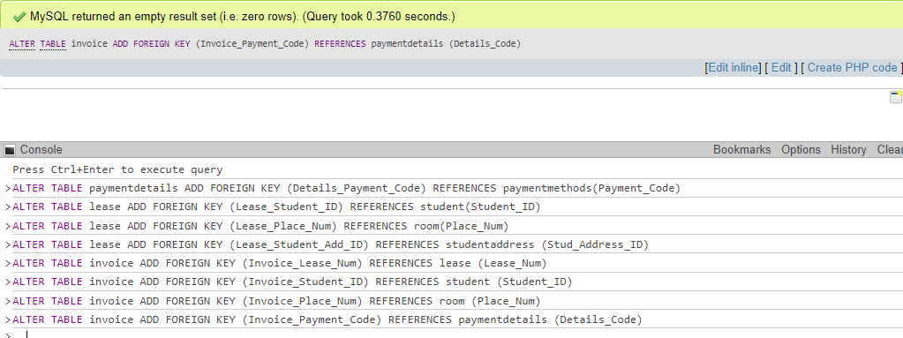

ALTER TABLE student

ADD FOREIGN KEY (Stud_Home_Add_ID)

REFERENCES

homeaddress (Home_Add_ID);

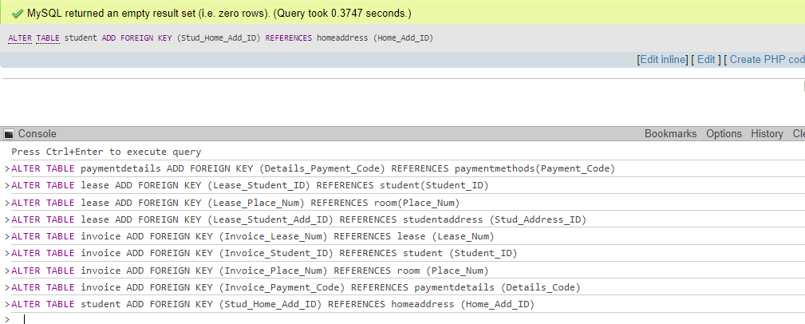

ALTER TABLE student

ADD FOREIGN KEY (Student_NOK_ID)

REFERENCES

nextofkin (NOK_ID);

ALTER TABLE student

ADD FOREIGN KEY (Student_Course_ID)

REFERENCES

Courses (Course_ID);

ALTER TABLE student

ADD FOREIGN KEY (Student_Address_ID)

REFERENCES

studentaddress (Stud_Address_ID);

ALTER TABLE uniaccomodation

ADD FOREIGN KEY (Uni_Accom_Staff_ID)

REFERENCES

staff (Staff_ID);

ALTER TABLE uniaccomodation

ADD FOREIGN KEY (Uni_Accom_Add_ID)

REFERENCES

address (Add_ID);

ALTER TABLE studentaddress

ADD FOREIGN KEY (Stud_lease-ID)

REFERENCES

lease (Lease_Num);

ALTER TABLE studentaddress

ADD FOREIGN KEY (Stud_Place_Num)

REFERENCES

room (Place_Num);

ALTER TABLE studentaddress

ADD FOREIGN KEY (Stud_Student_ID)

REFERENCES

Student (Student_ID);

ALTER TABLE flatinspections

ADD FOREIGN KEY (Inspect_Staff_ID)

REFERENCES

staff (Staff_ID);

ALTER TABLE flatinspections

ADD FOREIGN KEY (Inspect_Place_Num)

REFERENCES

room (Place_Num);

ALTER TABLE staff

ADD FOREIGN KEY (Staff_Location_ID)

REFERENCES

uniaccomodation (Uni_Accom_ID);

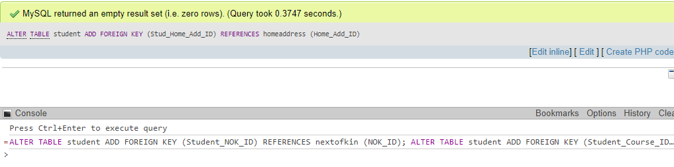

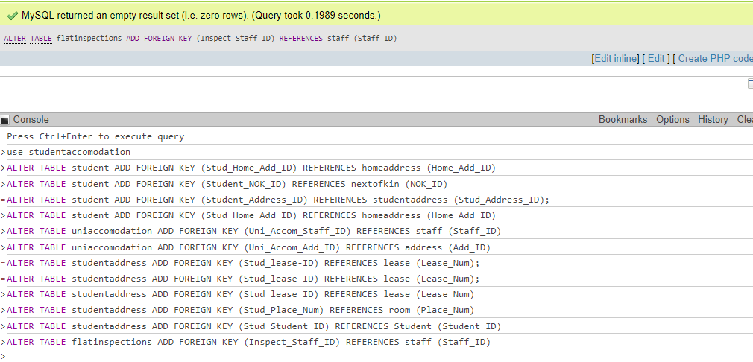

# Unique Constraint on Primary Keys

